Future Lady Owl Athlete,
Congratulations on the next step of your life, entering high school! We are excited that you chose to come to Garland High and join our athletic program. This, just like every other step, will be an adjustment, and we would like to help make it as smooth as possible. We are looking forward to seeing you over the summer, getting to meet you, and helping you become the best student-athlete possible.
A few things:
- This summer, we will have summer workouts, and this is our first opportunity to get to work with you. The workout calendar is attached, and most coaches will be working throughout the summer. We strongly encourage you to participate throughout the summer, get to meet some of your future teammates, and help us build the best you and best athletic program.
- Volleyball Tryouts will begin on August 1st, 2022. We will meet at Garland High School starting 7:30 am for the first session of tryouts. There will be a second session that day as well. Tryouts are Monday, Tuesday, and Wednesday and you must be present all days. Meet with Coach Fuller or Coach Butler.
- Cross Country (for any distance runners and offseason soccer players,) starts August 1st, 2022. You will meet at the high school at 7:00 am, with Coach Duyck, Coach Sampson. You will meet on the porch of the girls gym.
- All athletes must have a physical before they can participate in tryouts. There are also release forms that need to be signed online and completed, all of this information can be found on our www.garlandisd.schools.net/ghs Click on athletics, at the top of the screen it should read Athletes and Parents: GISD Athletic Instructions and Forms Here scroll down until you see athletic forms-athletic forms system, click and follow the instructions.
- Softball will have workouts at GHS on Tuesdays and Thursdays from 9-10:30 and open field on Wednesdays from 11-1.
- Basketball will have workouts the month of June (see attached calendar)
- Volleyball will have workouts June and July, as well as a team camp in July for all current athletes and incoming 9th graders (see attached calendar)
- Soccer will have a summer soccer camp for 6th-incoming 9th graders June 20-22nd @ Williams Stadium 1:00-3:00.
Visit our website for updates over the summer www.garlandowls.com

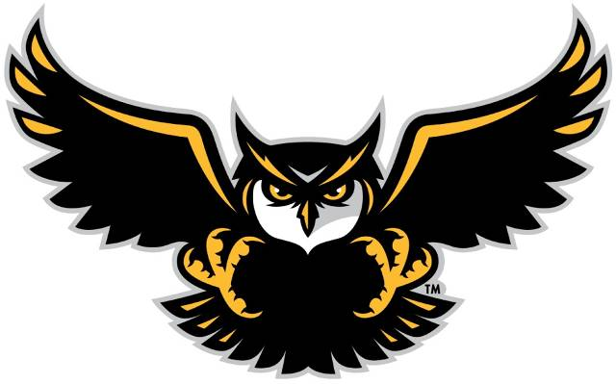

Garland High School Female Athletic Coordinator- Jennifer Sisson- jmsisson@garlandisd.net
Lady Owl Volleyball Coaching Staff
Instagram @ghsladyowlsvb
Amberly Fuller- Head Coach aefuller@garlandisd.net 469-231-2110
Jasmine Butler-Asst. Coach jrbutler@garlandisd.net

Lady Owl Cross Country/Track Staff
Lynn Duyck- Head Coach blduyck@garlandisd.net 214-629-5111
Stacy Sampson-Asst. Coach ssampson@garlandisd.net

Lady Owl Basketball Staff
Courtney Blankenship-Head Coach cblankenship@garlandisd.net
Timothy Davis-Asst. Coach tjdavis@garlandisd.net
Ted Ford- Asst Coach dtford@garlandisd.net

Lady Owl Soccer Staff-
Instagram @ghs_ladyowlsoccer
Twitter @GTownOwlSoccer
Krystal Mikeska- Head Coach kmikeska@garlandisd.net 469-744-0856
Jasmine Butler-Asst. Coach jrbutler@garlandisd.net

Lady Owl Softball Staff-
Jennifer Sisson- Head Coach jmsisson@garlandisd.net 214-334-4125
Amberly Fuller- Asst. Coach aefuller@garlandisd.net
Ted Ford- Asst. Coach dtford@garlandisd.net

